ICONIUM PRODUCTS

Thank you for purchasing Iconium Lighting Bollards
These products are made from responsibly sourced timbers
They will over a period split and check. This is normal and to be expected from a natural material.

Installation
These products are designed to be sunk at least 250mm into the ground and secured either with concrete or well packed hardcore depending on ground conditions. Care should be taken to ensure the product is upright and secure.
These products must be connected by a qualified electrician and most importantly not tested with a high voltage test meter; this could cause irreparable damage to the lights which would not be covered by the warrantee

Maintenance
Your product needs little maintenance, however an application of a linseed oil based product will be beneficial from time to time. Replacement luminaires are available from Iconium and must be installed by a qualified electrician

Data
1.3w LED COB (non-replaceable) 240V ~ 50Hz IP67

PLEASE NOTE
THE FLEXIBLE CABLE OF THIS LUMINAIRE CANNOT BE REPLACED – IF DAMAGE OCCURS THE LUMINAIRE MUST BE REPLACED
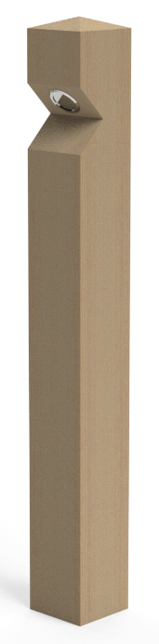

October 2025

