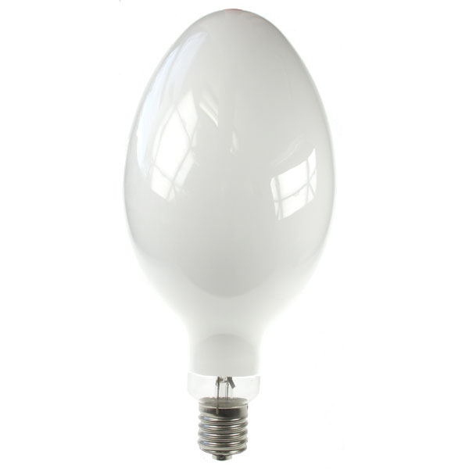
MBFU 1000w Specs
Description – E40 Mercury 1000w Coated
Kelvin – 4000k
Wattage – 1000w
Lumens – 60,000lm
Amp – 7.5amp
Voltage – 145
Diameter Total – 180mm
Length – 390mm
Base – E40
Rate Life – 10,000hrs

